Ensure that all centres should be sanitized a day prior to the examination. This is a sensitive step as several malpractices have been found due to the nexus of the workforce responsible for sanitisation.
Testing Centres should be sealed in the presence of the District Administration and Police and should be
guarded till the centre is de-sealed for the examination in the presence of District Administration and NTA officials.
Establish a CCTV Monitoring Centre at the District level. This should be manned by the NTA and District Admin officials. The CCTV Monitoring Centre should strictly monitor all the CCTV footage, and it should also be ensured that all the DVRs/NVRs are being secured and deposited to NTA safely on the day of the
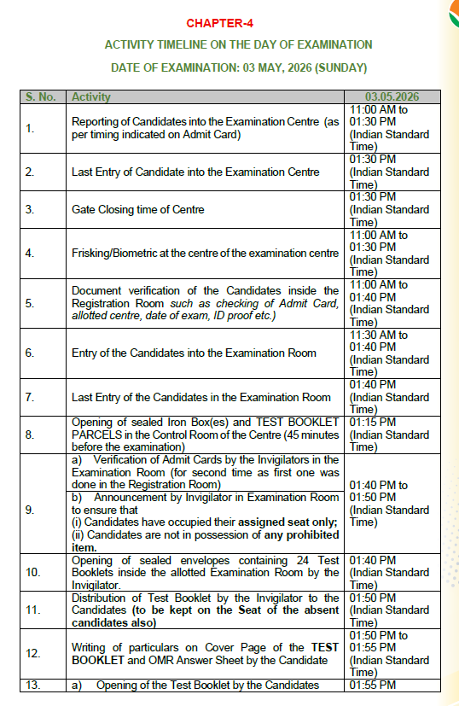
examination.

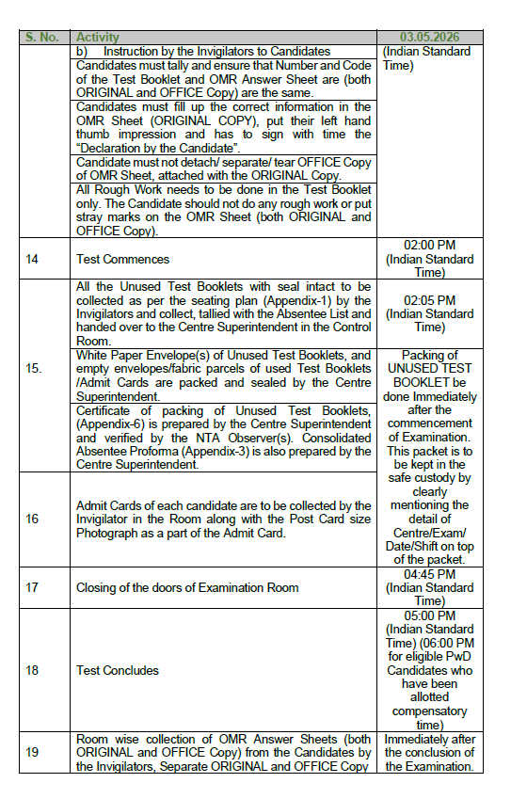
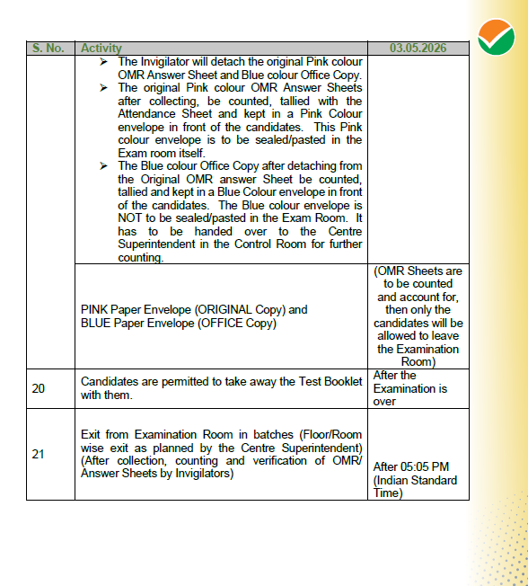
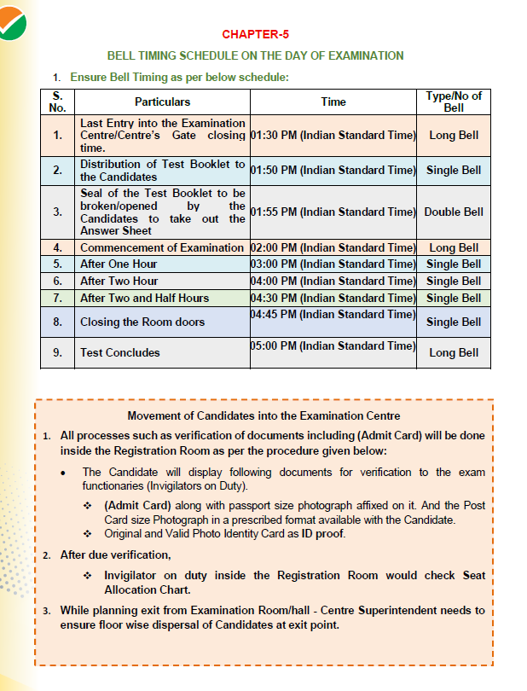

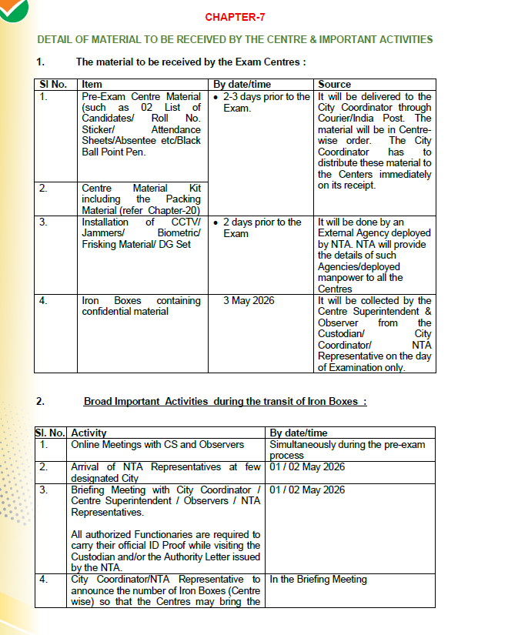
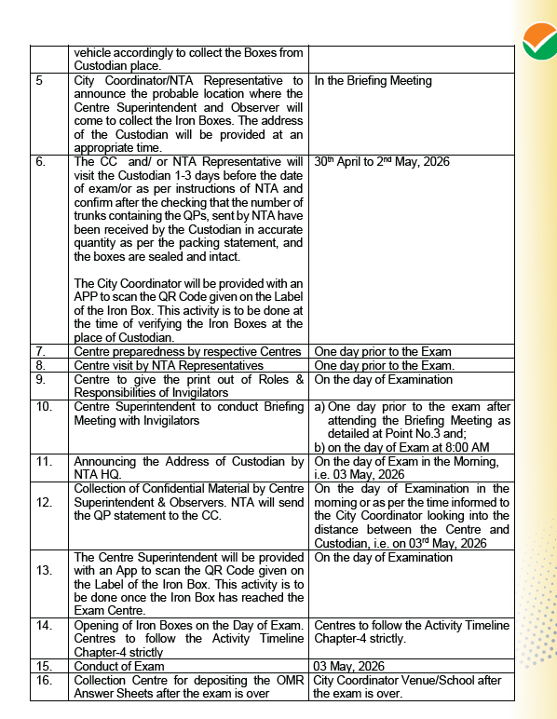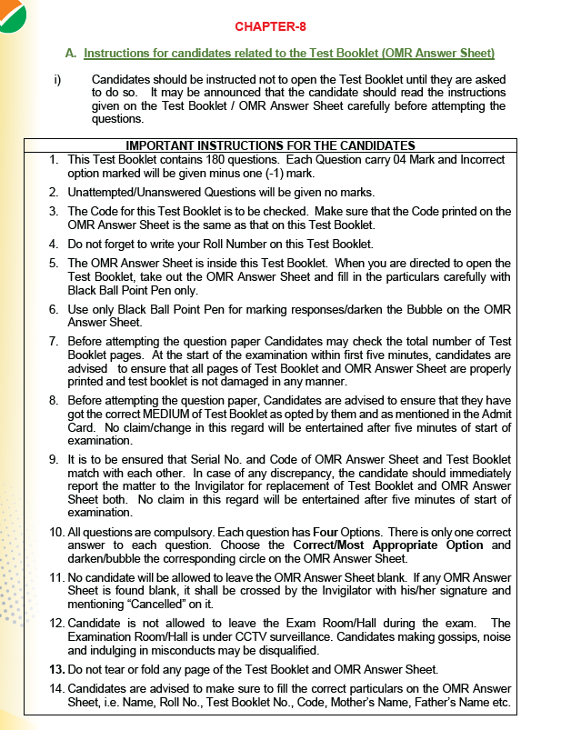

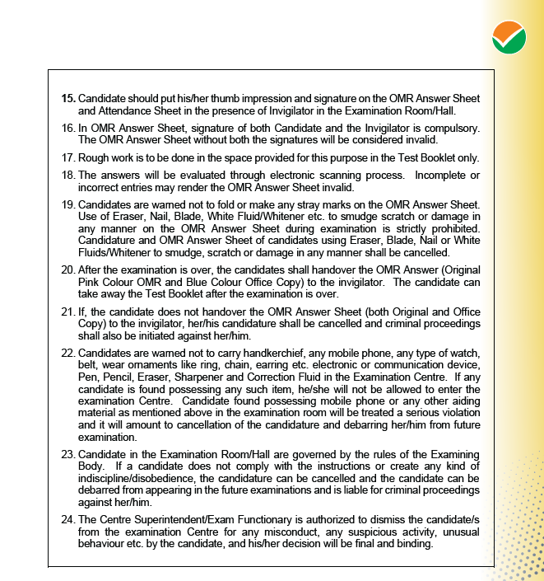

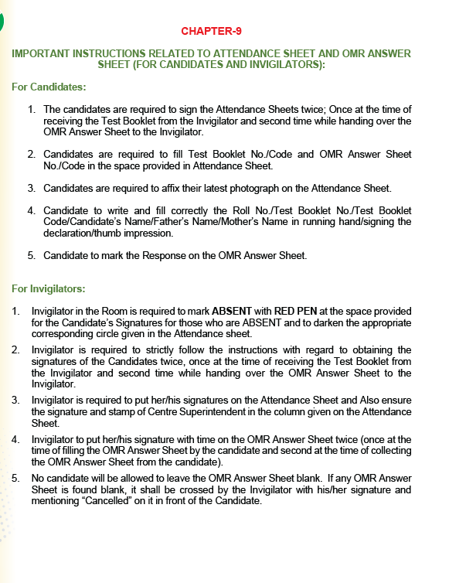

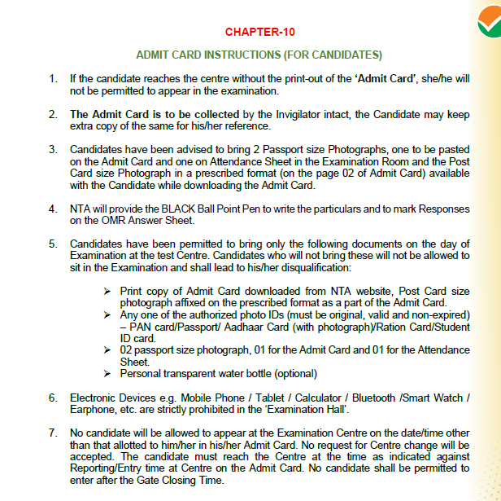

- Presence of at least 2 Invigilators and 2 Candidates should be recorded on top of the envelope along with their names and signature, while opening the seal of the trunks.
- Announcement by Invigilators to the Candidates that if any of the Candidates in the Examination Room is using any unfair means, the same may be objected and brought to the notice by the other Candidates appearing in the Examination.
- Invigilators will get an envelope containing 24 Booklets in it. This Envelope needs to be opened in the room/hall where the Candidates are sitting. Small scissors may kindly be provided in each room/hall. While cutting this packet, it should be ensured that the Test Booklet inside the Packet are not damaged.
- Issue of Identity Cards to the Examination Officials and staff.
- Procedure for opening of question paper parcels/packets, sealing of Answer Sheets etc.
- Police and security arrangements.
- Information regarding the place of Custodian and approximate number of iron boxes to be communicated to the Centre Superintendents so that they can bring suitable covered vehicle along with Group-IV employees for safe transportation of question papers in Iron Box(es).
- Place for submission of material by the Centres (after the Examination) willbe at the venue of the City Coordinator, which is called Collection Centre(post exam.
- No Relation Certificate to be obtained from all the staff engaged during the examination.
- The Centre Superintendent will attend the Briefing/ Meeting to be arranged at time communicated by City Coordinator) TWO day prior to the Examination.
- The Centre Superintendent will ensure that the Material (Details of Materialto be received by the Centre & Important Activities) as described in Annexure-I and Chapter-4 has been received well in time as per timeschedule.
- Centre Supdt. is required to print the “Activity Timeline” (As described in Chapter-4) and give its copy to the Invigilators for implementing the same in the Examination Room on the day of Exam.
- Big Registration Rooms/Halls, one each for boys and girls. The gates of the Examination Centre should be opened 3 hours before the specified time of commencement of the Examination, i.e., 11:00 A.M. No Candidate who reports after the last entry time be allowed to enter the Examination Centre.
- It is to be ensured that female candidates are being frisked by a Female Guard/staff and the Male candidates are being frisked by a Male Guard/Staff. The frisking of Female Candidates is strictly to be done in a close Enclosure/Canopy. Further, the frisking should be done a sophisticated manner, it should not lead to any undue harassment to the candidate.However, on suspicion, even the candidate be asked for checking/verification during the Exam as well.
- Document verification desk to be set up inside the room/hall and would be managed by Invigilators on Duty. As number of Candidates per room is 24, one of the Invigilators may be involved in this pre-Examination task as per the roster, before the Examination begins.

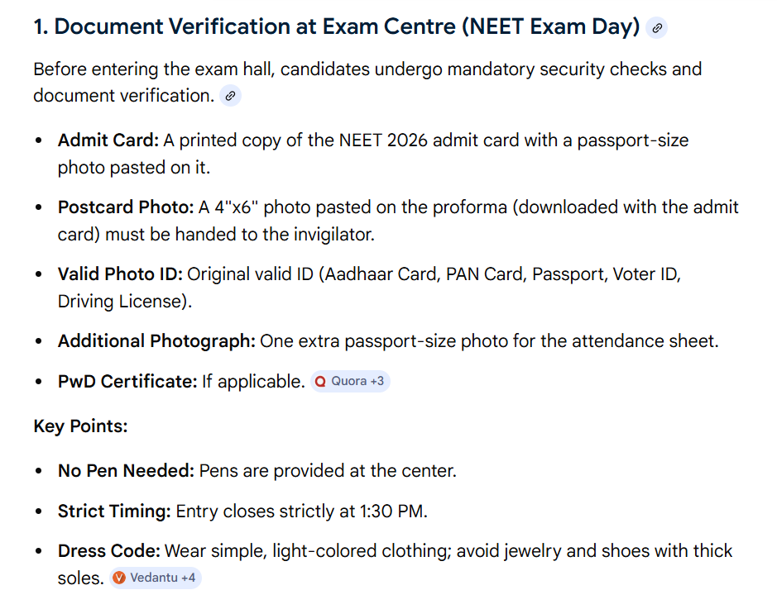
- School/Institute Guards at the entrance would ensure that every Candidate would pass through the Registration Room to complete three steps i.e. Registration & Verification / Biometric / Frisking (refer Chapter-16)
- Facsimile Signature/stamps of Centre Superintendent in adequate number to affix on each Attendance Sheet. Stamps to be kept in the safe custody of the Centre Superintendent to avoid any misuse.

- The Centre Superintendent shall contact Commissioner of Police of the area for deputing at least four policemen and one Sub-Inspector in uniform at the Centre to maintain law and order for the smooth and fair conduct of Examination. NTA has also written a Letter to the Commissioner of Police,DGP, SP of respective City. A copy of thesame has been shared with all the Centres.
- Centre Superintendent to prepare a roster of Invigilators on duty in Registration room. So that any single Invigilator does not get stressed and exhausted. Duty slots of 30 minutes each may be planned, if required.
- A Chart showing Roll Number of Candidates allotted in each room must be pasted outside and inside each room for identification of seats by the Candidates.
- List of staff on Examination Duty, i.e., list of Invigilators, Clerk(s)/Class IV Staff be displayed in the room of Centre Superintendent/Control Room.
- A timeline of different activities to be adhered to by the Centre Superintendent as given in Chapter-4.
- Bell Timing schedule as given in Chapter-5.
- Centre Superintendent needs to prepare the Absentee Statement sent by the NTA immediately after commencement of the Examination. For filling up the Absentee Proforma, Centre Superintendent needs to darken the Appropriate Circles with Black Ball Point Pen against the Roll No. of Candidates who are “Absent”. Do not use a Red / Green Pen. In case of shortage of any Absentee Pro forma, Proforma provided in Appendix-3 may be printed and used.
- The Centre Superintendent shall provide an authorized Identity Card supplied by the NTA to all officials associated with the conduct of NEET (UG) 2026. The Identity Card must bear the name, designation and signature of the official on duty. No official may be allowed on duty without an Identity Card.
- Diabetic students will be allowed to carry eatables like sugar tablets/fruits (like banana/apple/ orange) to the Examination Room. However, they will not be allowed to carry packed foods like chocolates/candy/sandwich etc The NTA has modified the process of opening of Test Booklet packed 24 Booklets which need to be opened in the room/hall where the candidates are sitting. Small scissors may kindly be provided in each room/hall. Each individual Booklet will be wrapped in transparent plastic envelope which will be opened by candidate himself/herself.

